There is too much white vertical space above and below “Oysters”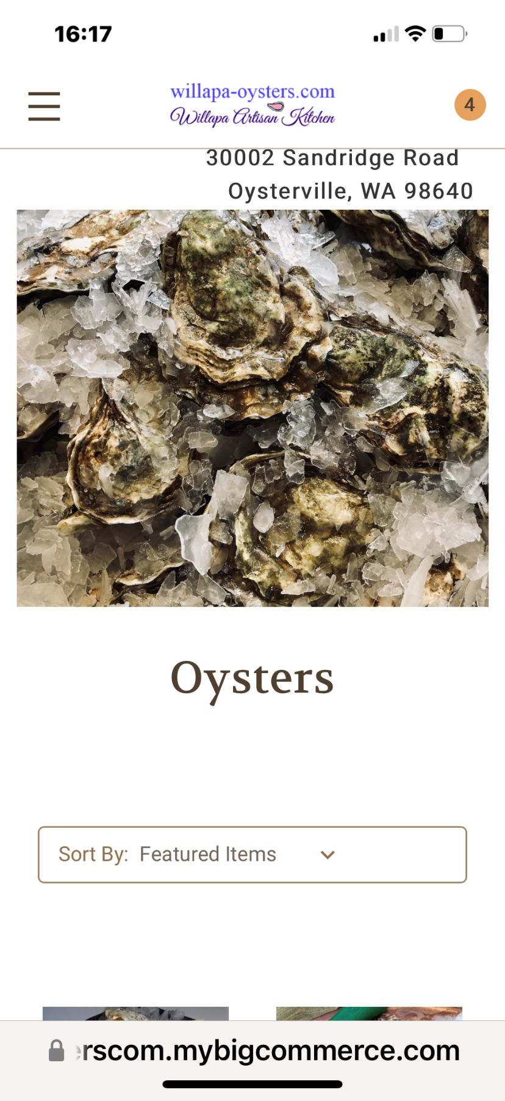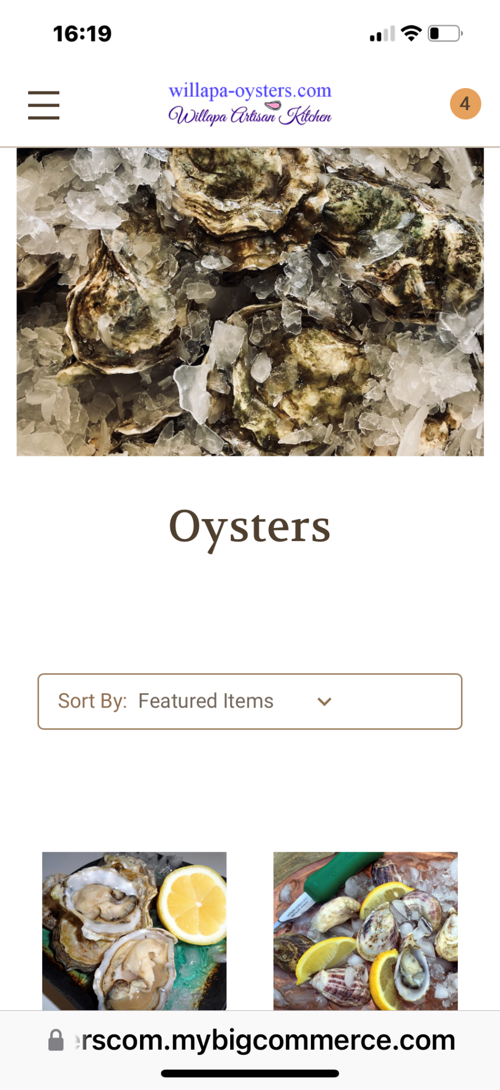
On desktop it’s worse. Customer has to scroll too much. Too much white space above and below the logo
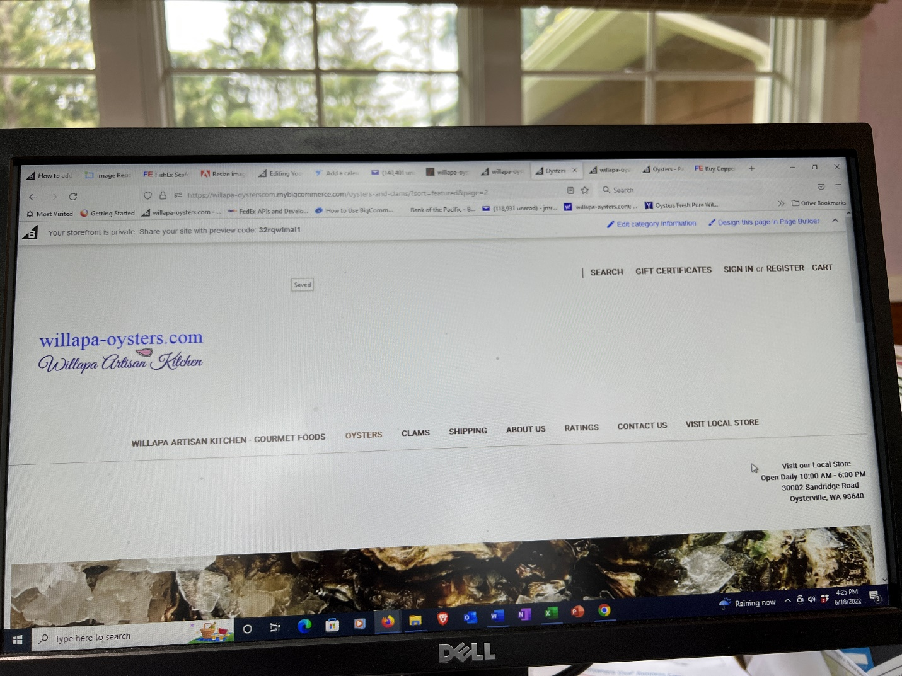

Rating page needs to fit on screen of iPhone in portrait mode
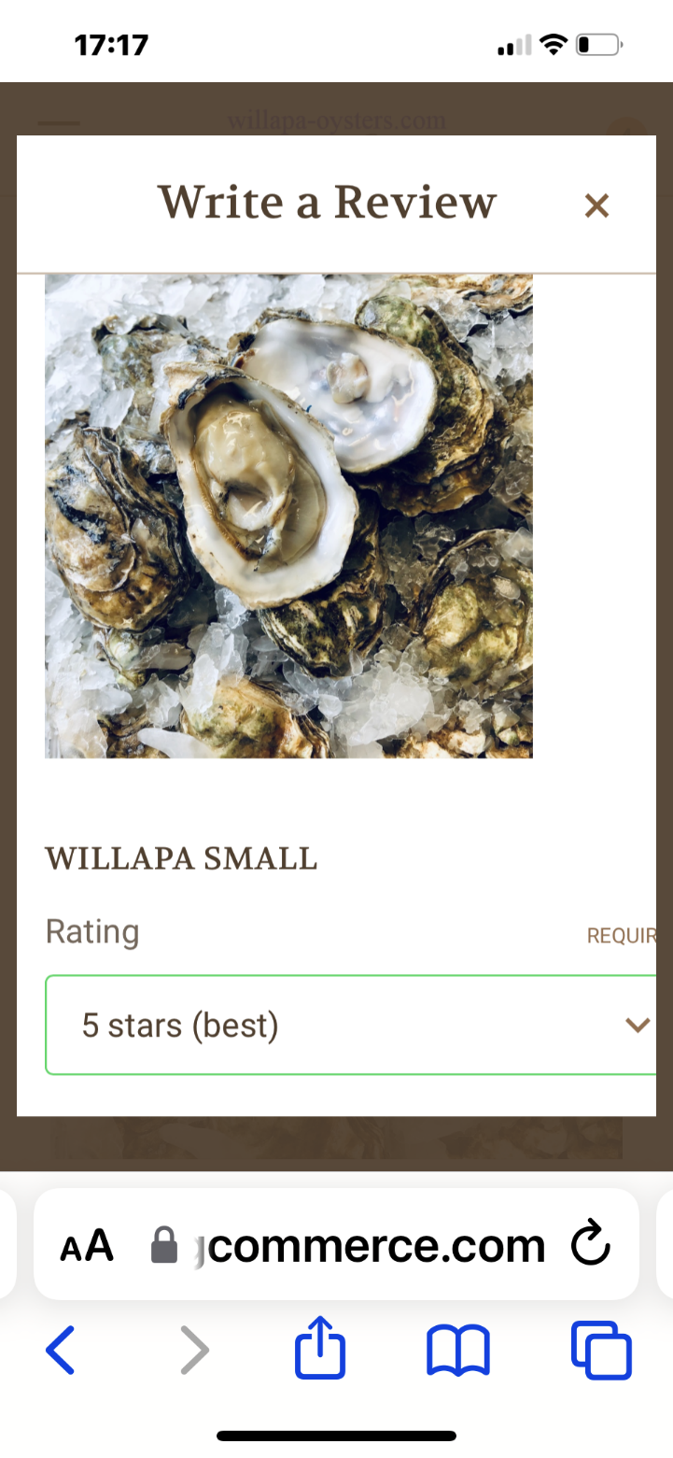

This screen shot shows all the unnecessary white space (padding) around logo and after title - Gourmet Foods –

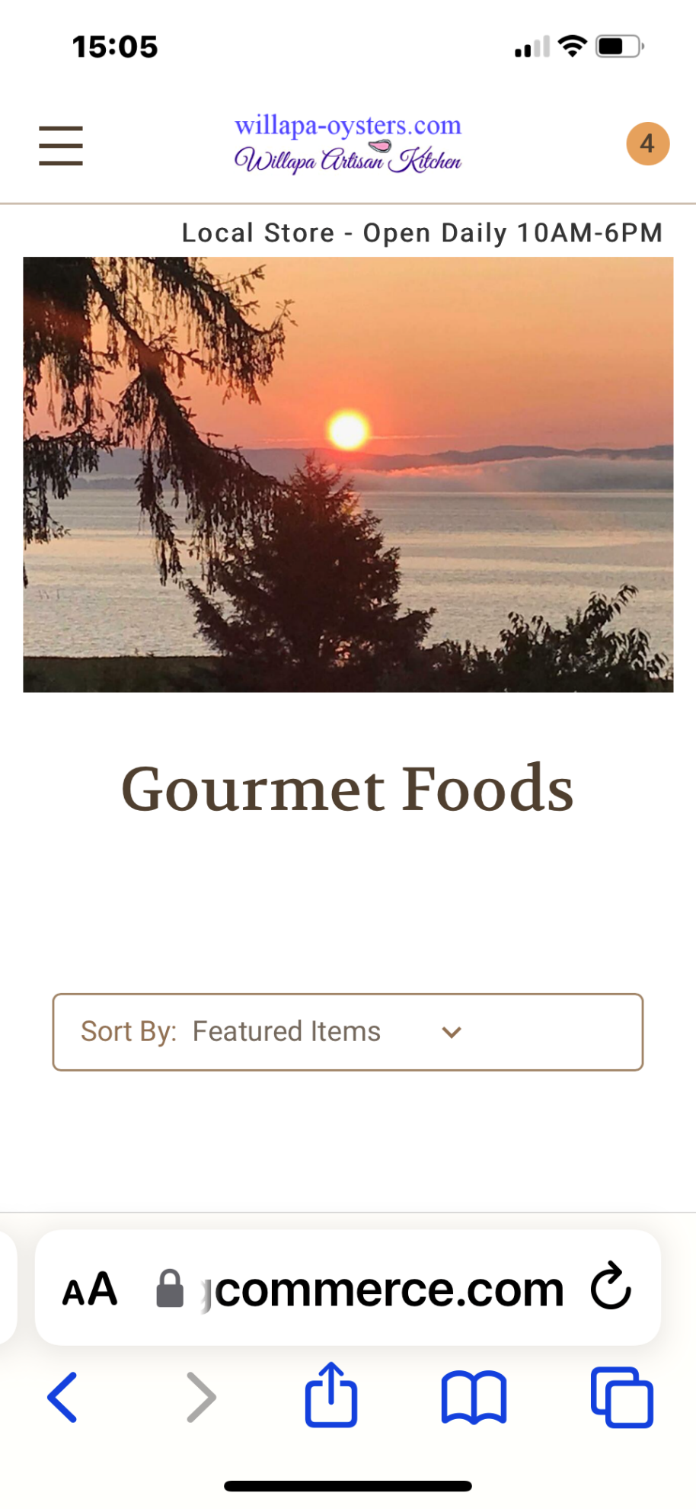

please add the add to cart button o products on the home page and on the grid view.

